Project Name: দেলিপাড়া জলদাস গাঁ:  **ত্রয়োদশ পার্বণের মহাউৎসব**

**Housing For Fishermen Community**

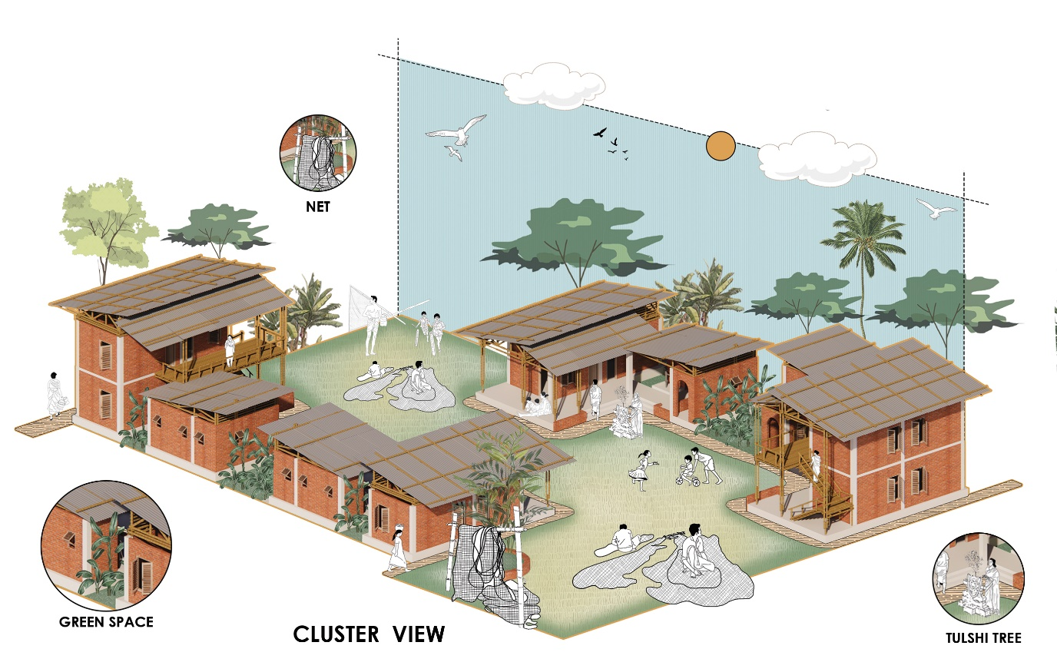

Cluster View © Diptenu Saha| PUST

Student Name: **Diptenu Saha**

Year: **2023**

Studio: **X (Thesis)**

Institute: **Pabna University of Science and Technology (PUST)**

Studio Teachers: **Sonjit Kumar Nath**

Typology: **Housing**

Height: **Single Storey 15 ft | Double Storey 25 ft**

Land Area: **13.50 acre**

Built Area: **1,96,020 sqft**

Basement: **None**

**L**ocation: **Delepara, North Salimpur, Chattogram**

**Location :**

Located in North Salimpur union, Chattogram, Delepara is a fisherman community village. Government proposed a housing project for the amelioration of the fisherman community of Delepara. While the government’s provision of 2,200 sqft area to each family with residential structures and facilities, the families are struggling to live properly because of unplanned settlement and lack of enough space for their ritual and daily activities. The proposed design concept aims to improve their quality of life by creating co-living spaces that foster social interaction and giving them enough space and facilities for creating belongingness in their living space and society.

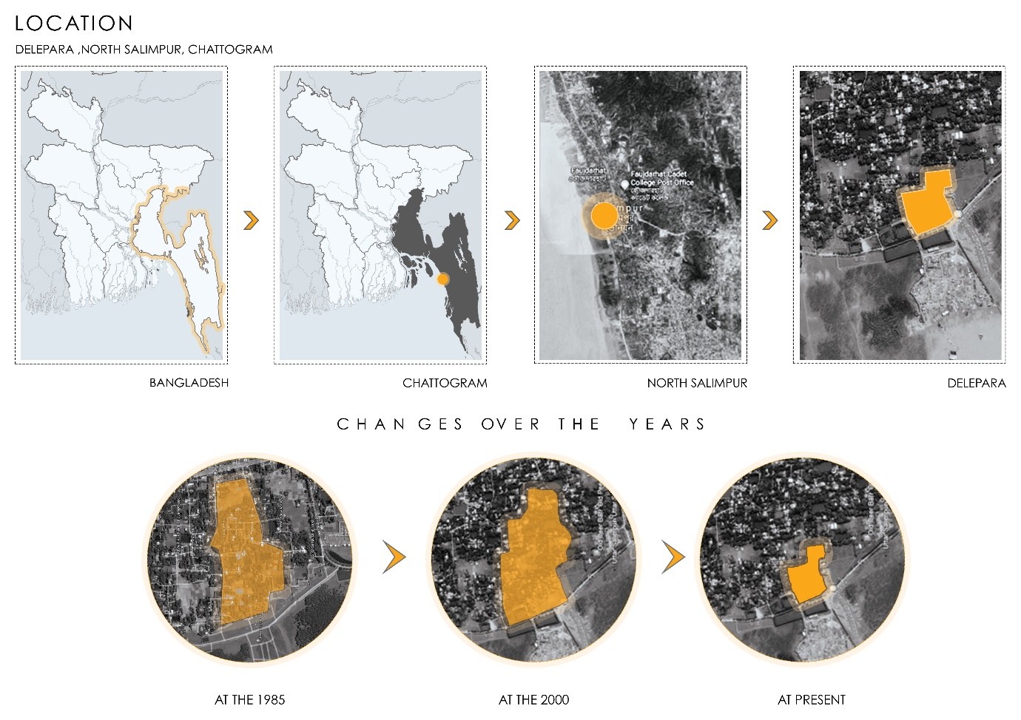

Location Map © Diptenu Saha| PUST

**Daily Activities :**

This community earns their bread by fishing. Most of the time in a day when they are not on sea for fishing, they are busy making their fishing nets, repairing them, looking after their fishing boats and arranging them in various designs.

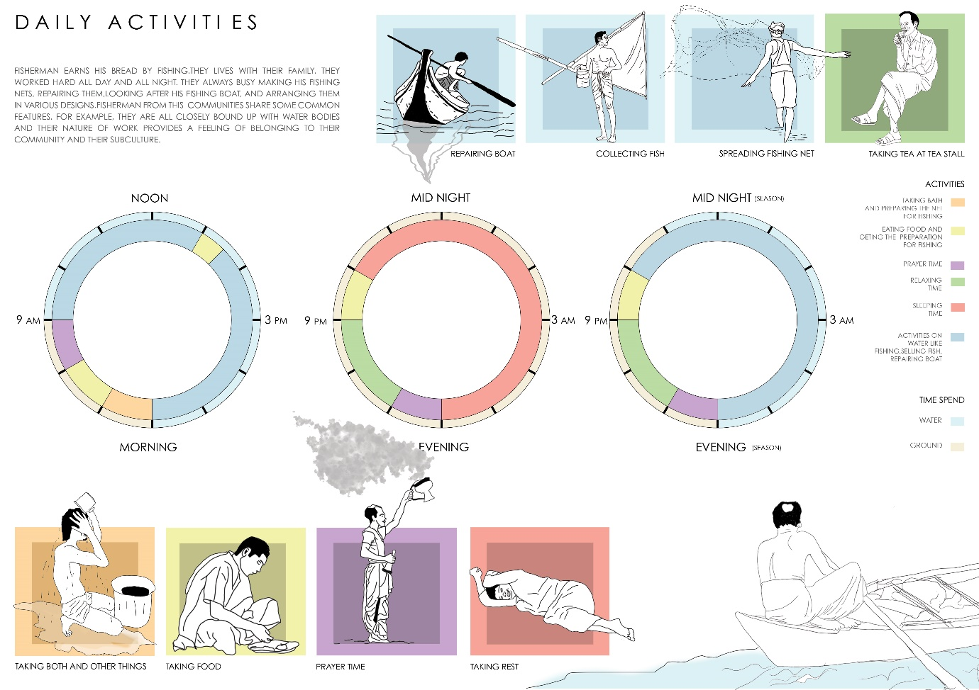

Daily Activities © Diptenu Saha| PUST

**Concept :**

In this community (জলদাস), 100% current people belongs from Hindu religion. In their lifestyle, the most colorful and vibrant things are the festivals which they celebrate through different puja and occasions. So, the idea is to give proper space around the existing temples to celebrate their puja and other festivals to create a sense of belongingness and preserve their rituals and traditions.

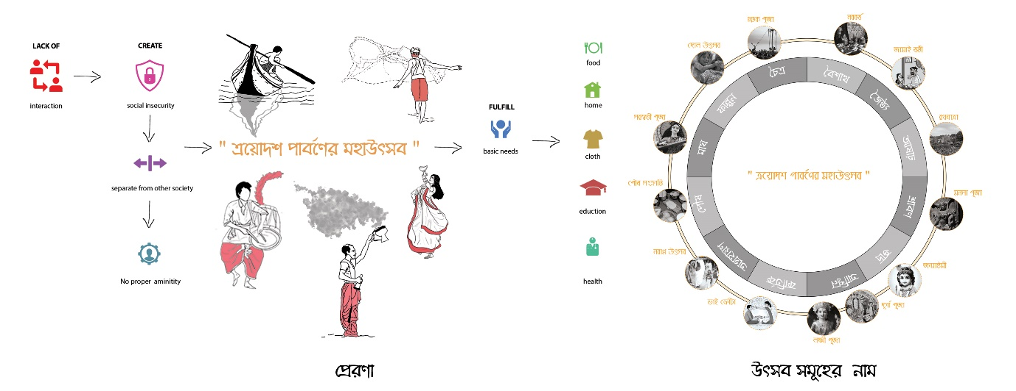

Concept © Diptenu Saha| PUST

**Occupant :**

There are 03 existing temples and 04 existing water bodies and 03 access points of the site. So, the idea is to create a central pedestrian road among the temples, water bodies and give a proper space for their ritual activities around the temples. Again linear shape space is required for fisherman’s preparation and repairing work. So, the idea is to design this settlement by giving a linear courtyard for their daily work.

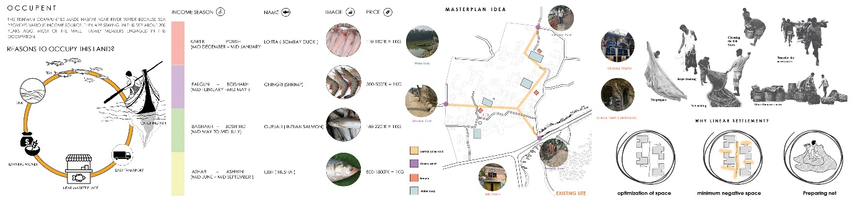

Occupant © Diptenu Saha| PUST

**Master Plan :**

The proposed master plan accommodates 120 housing units with functional courtyards in four zones around with four water bodies and existing temples. The inner courtyard helps them to manage their daily work like drying of paddy and pickle, children playing area, repairing the net in wet season etc. The outer court is used to dry the fish net, prepare or repair the net. A designed fish market in-front of the channel is proposed so that they can sell their fish to the local vendors. The amenities like pre-school, boat repairing workshop, community multipurpose hall, local market for daily needs and a central field for the playing are also provided in the design proposal.

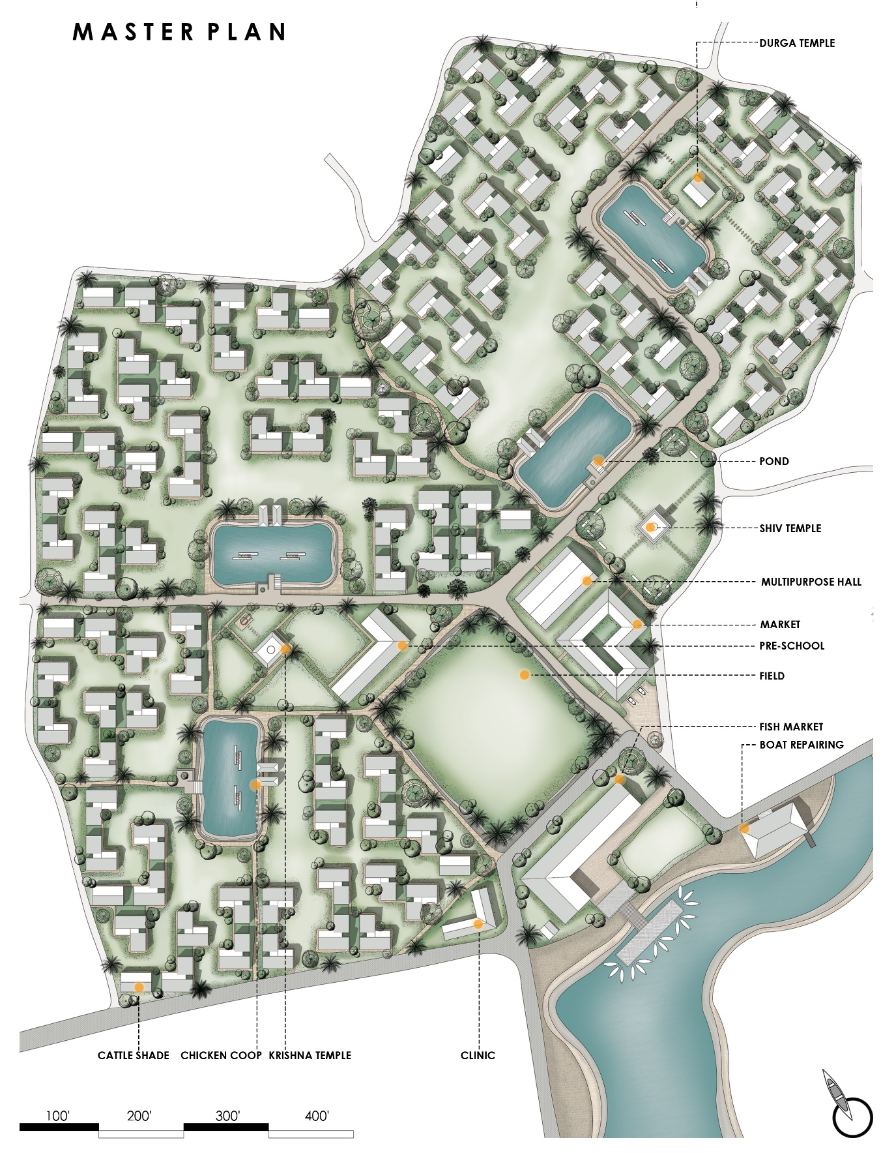

Master Plan © Diptenu Saha| PUST

**Units & Cluster :**

Each module consists of two bedrooms, one kitchen, one prayer room (pooja ghor), one bathing space, one separate toilet, one tubewell and a flexible courtyard consisting of a Holy Basil (Tulsi) tree for puja purposes. Total area of each module is 2200 sqft where there is a small courtyard (350 sqft) and green space (80 sqft) for cultivation.

In the cluster the idea is to join 02 inner courts to form a linear space for the fisherman’s daily works like repairing, preparing and drying the fishing net.

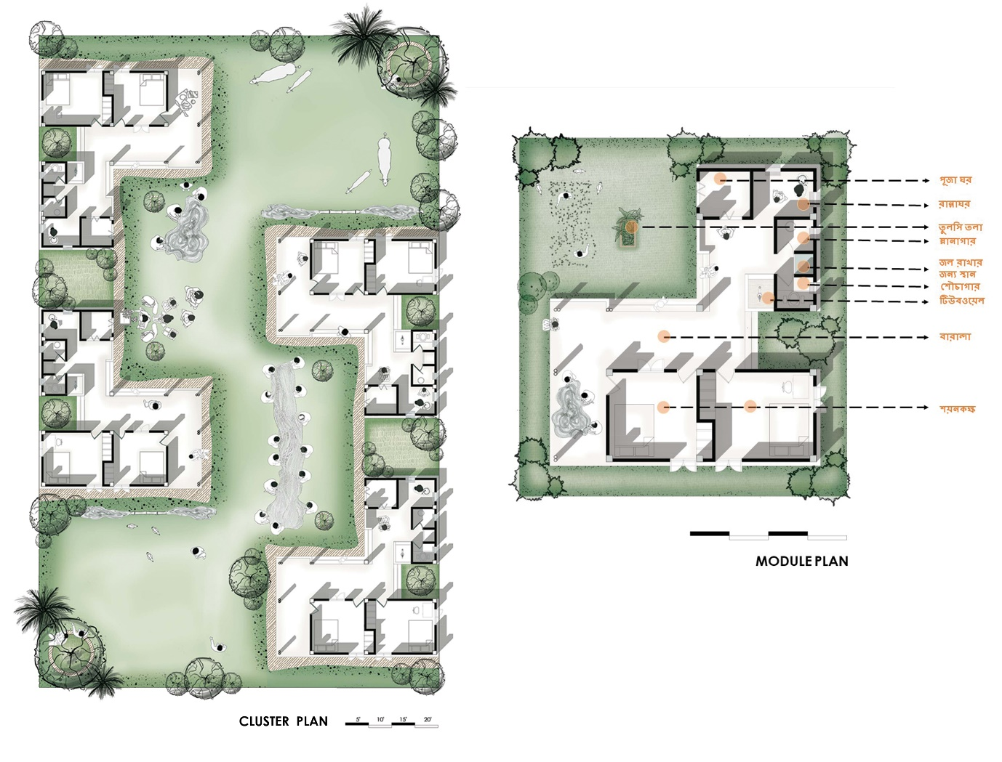

Units & Cluster © Diptenu Saha| PUST

The module can be extended vertically in future. It can be extended up to 02 or 03 more bedrooms if needed.

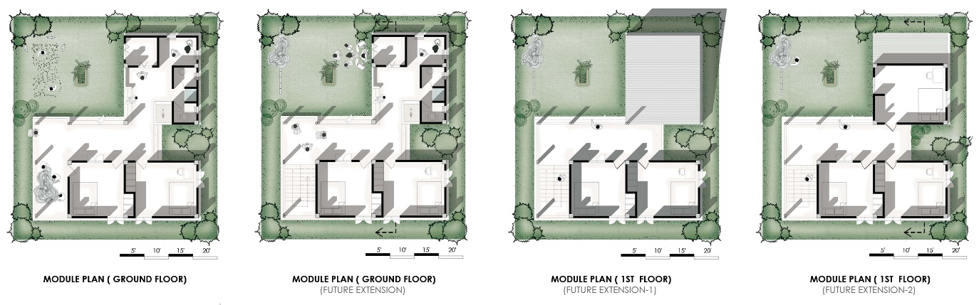

Module Plan © Diptenu Saha| PUST

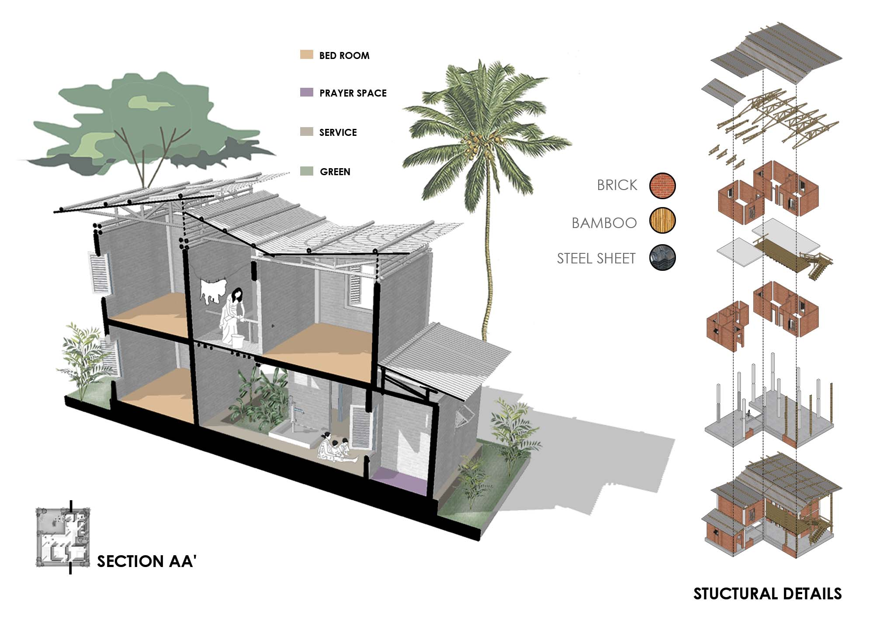

Section & Structural Details © Diptenu Saha| PUST

**Material :**

Locally sourced materials are prioritized in the construction process. The proposed module features a bamboo floor (future extension), a galvanized iron corrugated sheet roof, brick wall and concrete plinth. The windows are designed with louvres and double swing to maximize the daylight and natural ventilation while keeping privacy in the context of a rural community.

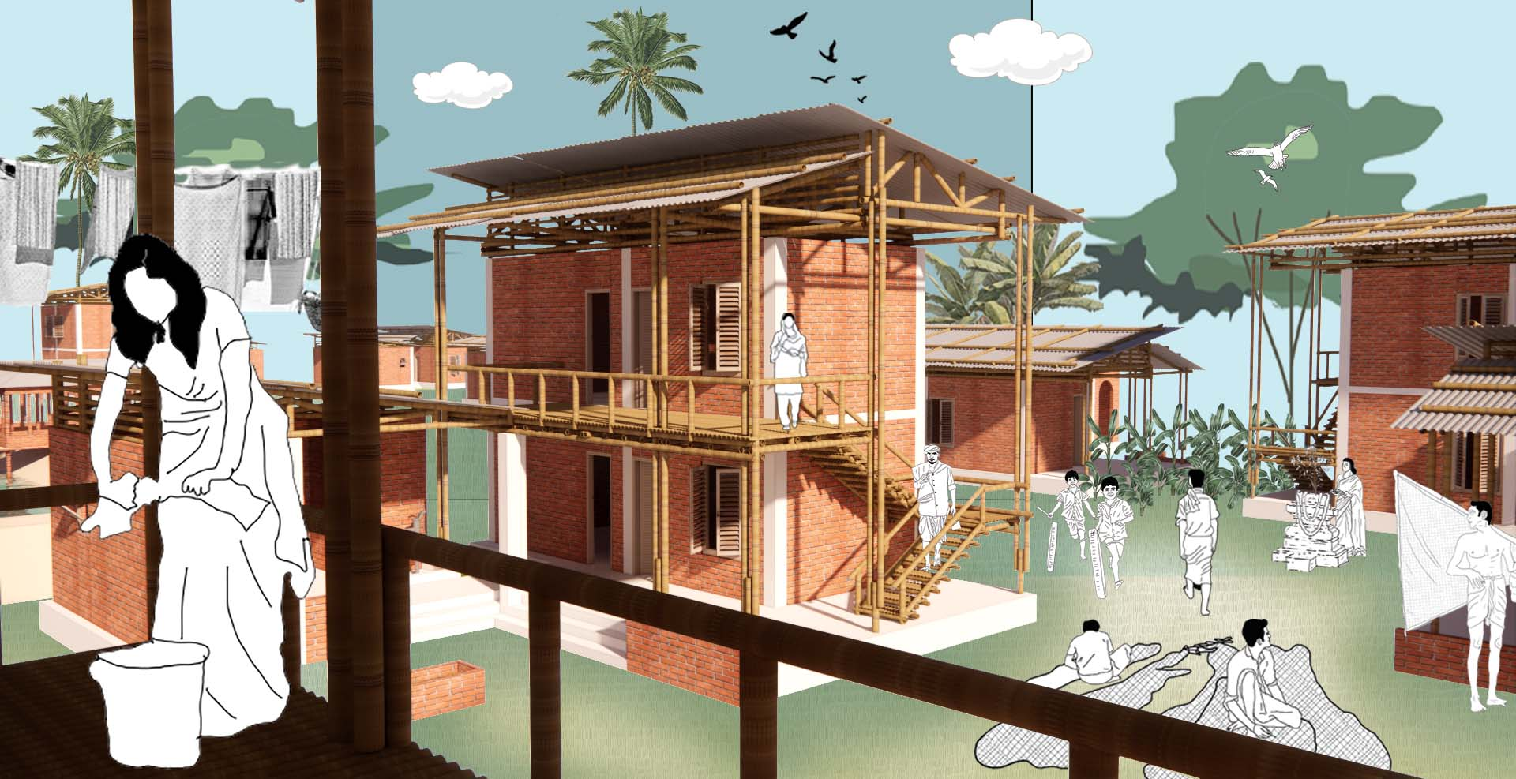

Render View © Diptenu Saha| PUST

**Fish Market :**

A fish market with loading-unloading, storage, weighing and buying zone is provided for selling the fishes to local vendors. Vendors come here with a small van or truck to load the fish and take it to the city market.

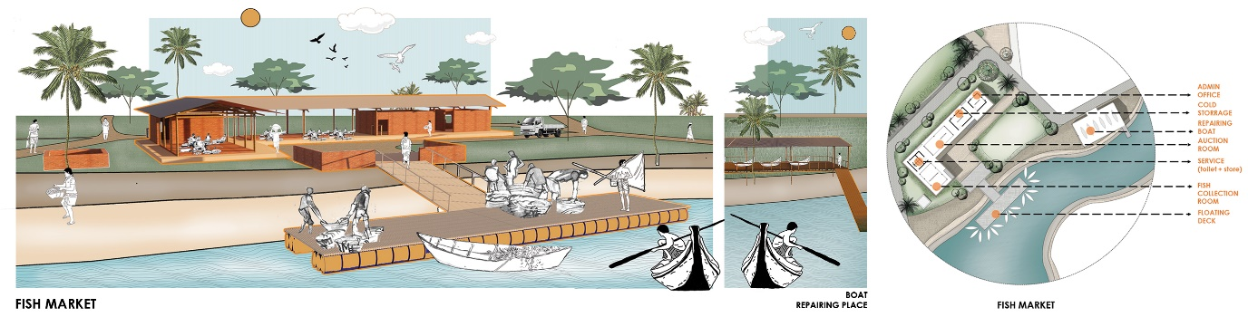

Fish Market © Diptenu Saha| PUST

**Market and Multipurpose Hall :**

A market is proposed and designed for the daily needs of this community and a multipurpose hall is also proposed for the recreation and training purpose.

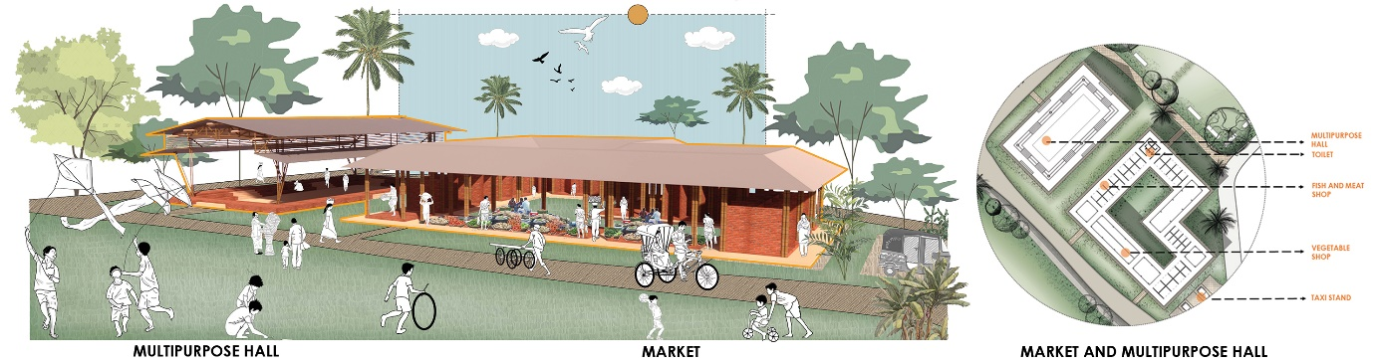

Local Market and Multipurpose Hall © Diptenu Saha| PUST

**Pre-primary School :**

A pre-primary school is considered and provided for the children of this community as there is no pre-school located near the community.

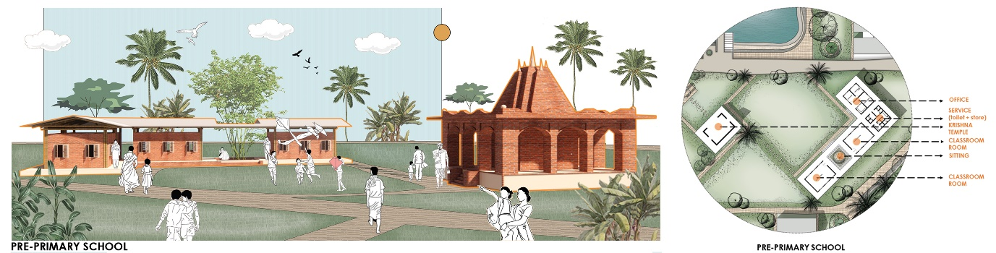

Pre-primary School © Diptenu Saha| PUST

**Community Clinic :**

Accidents and injuries are very common and regular for fisherman’s daily life. So a community clinic is designed with adequate facilities for the health issues of the fisherman and the community.

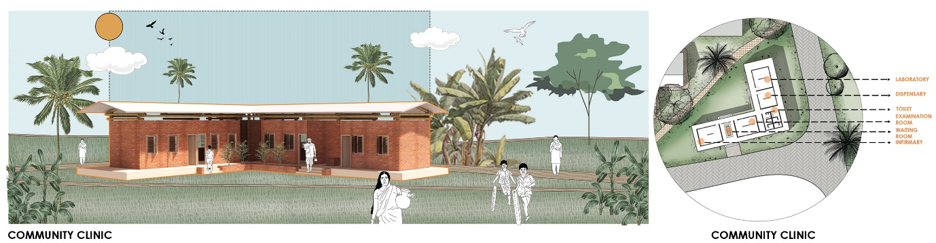

Community Clinic © Diptenu Saha| PUST

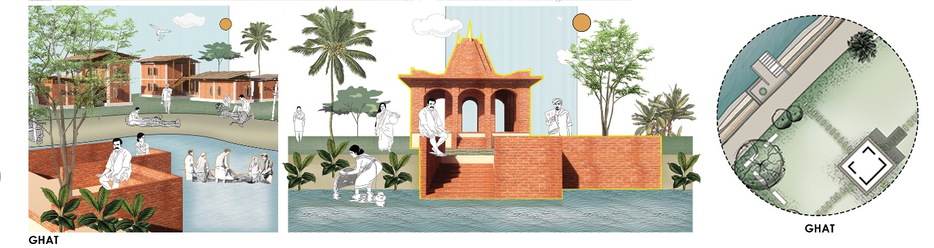

Activities of Ghat © Diptenu Saha| PUST

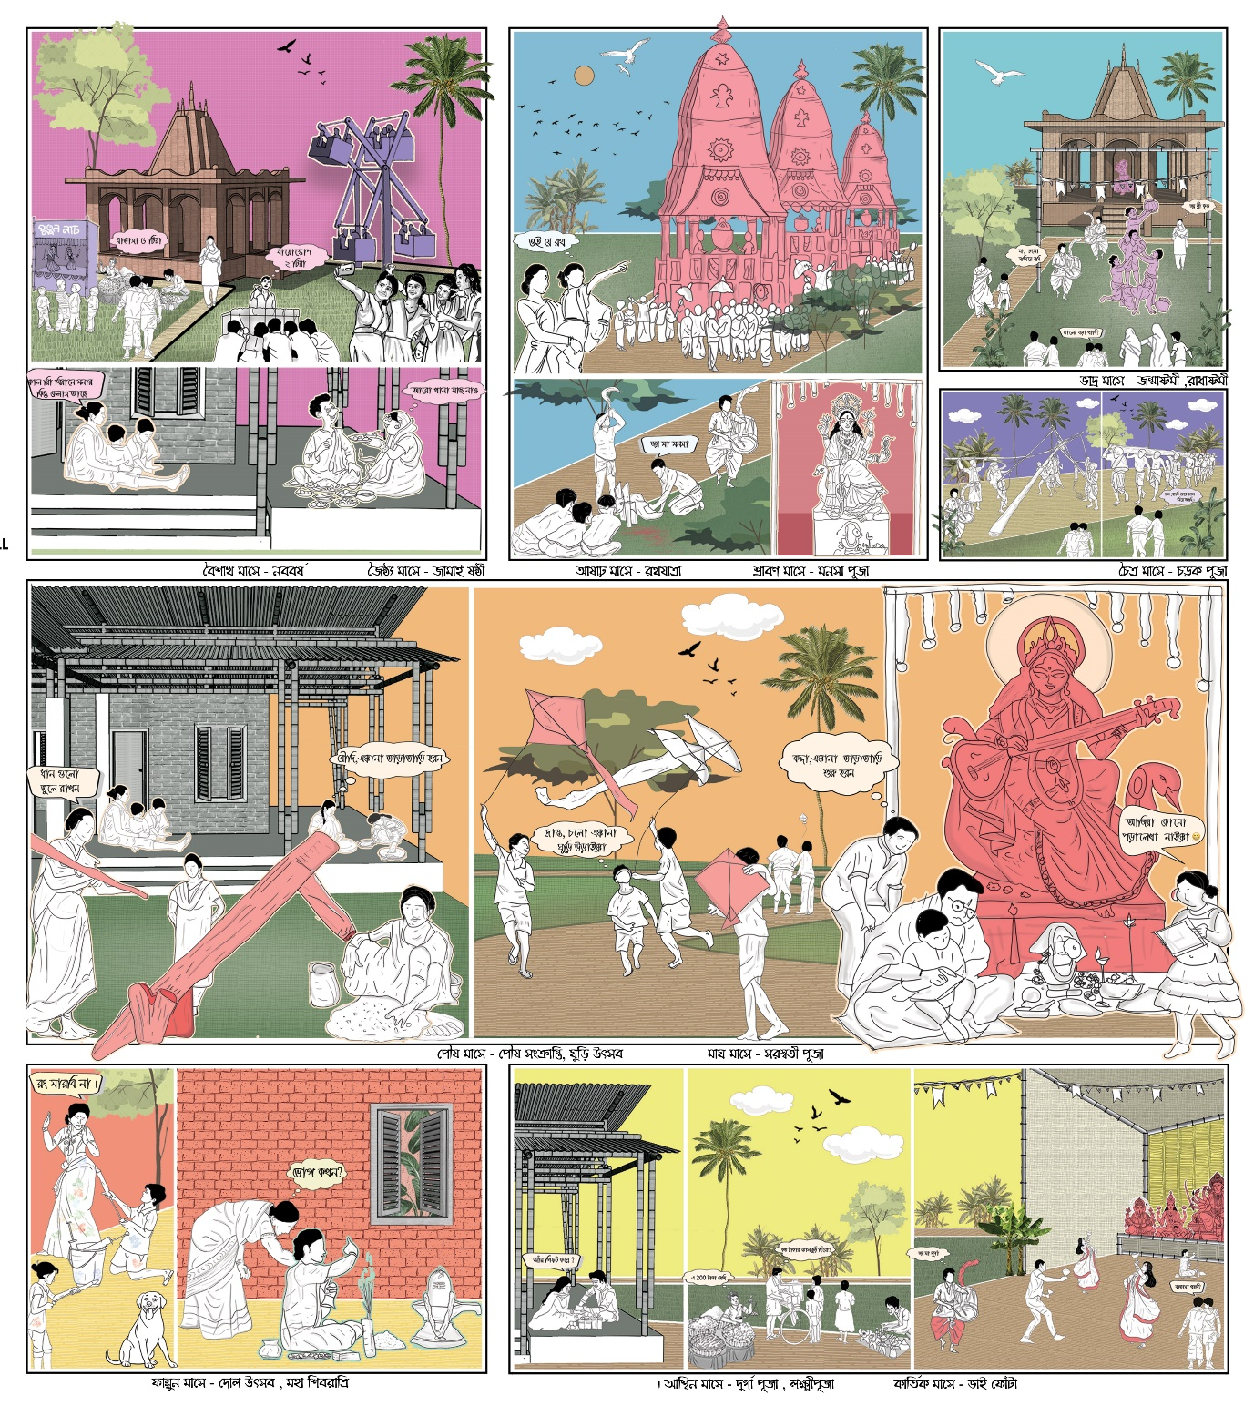

Festival (ত্রয়োদশ পার্বণের মহাউৎসব)© Diptenu Saha| PUST

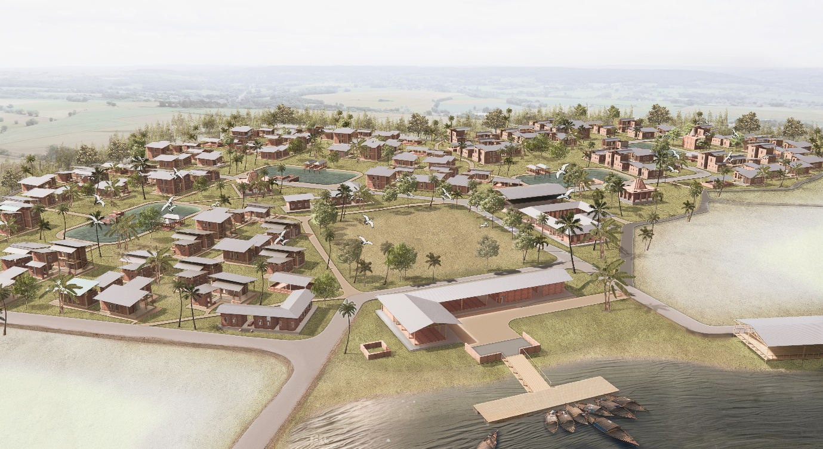

Aerial View © Diptenu Saha| PUST

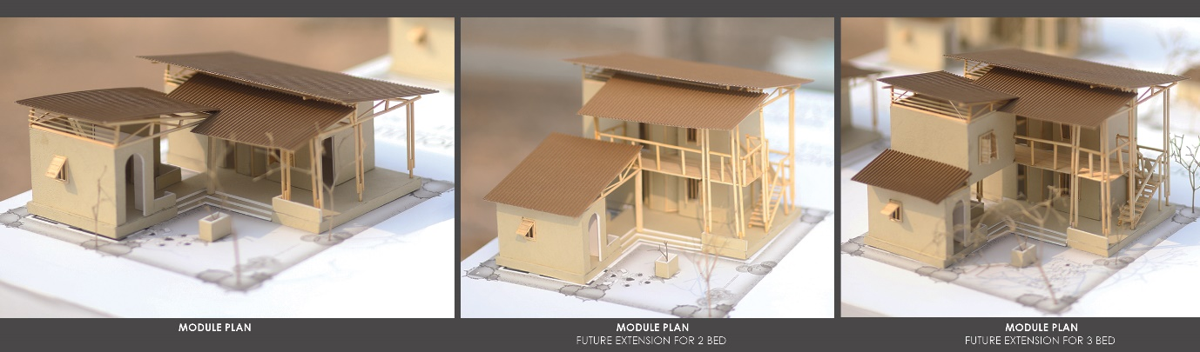

Model © Diptenu Saha| PUST